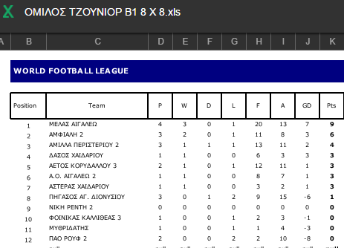[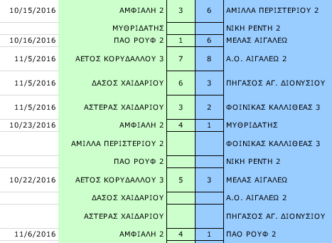](http://www.youngtalents.gr/academies/wp-content/uploads/2016/11/ShooterScreenshot-239-08-11-16.png)[shooterscreenshot-240-08-11-16](http://www.youngtalents.gr/academies/wp-content/uploads/2016/11/ShooterScreenshot-240-08-11-16.png)